Revista Brasileira de Paleontologia, 24(3):205–235, Julho/Setembro 2021
A Journal of the Brazilian Society of Paleontology
Piñeiro et al._ MESOSAUR TAXONOMY REAPPRAISAL: ARE STEREOSTERNUM AND BRAZILOSAURUS VALID TAXA? doi:10.4072/rbp.2021.3.04

Table 2. Cervical and presacral counts for Mesosaurus, Stereosternum and Brazilosaurus obtained from the available literature and the present study. The table includes a photograph of specimen GP-2E 644 showing the count of presacral vertebrae for all mesosaurs according to our studies. Scale bar = 20 mm.
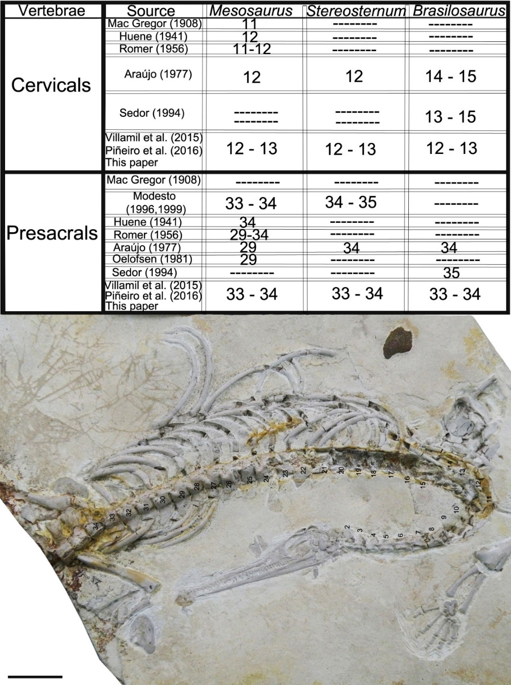

Table 3. Length average of the available mesosaur specimens in our sample which preserve skull or/and mandible with teeth. “Taphonomic influence” means that longer teeth could have not been preserved and we calculate the rate for just a few teeth of similar size.
Specimen number | Tooth lenght mean (mm) | Observations
GP-2E 644 | 35 | Young adult
GP-2E 669 | 33 | Adult
MCN-PV 2158 | 18 | Adult (possible taphonomic influence)
GP-2E 296 | 30 | Adult
MCN-PV S/N | 44 | Adult
SMF-R-4512 | 17 | Juvenile
SMF-R-4934 | 31 | Adult
SMF-R-4513 | 17 | Juvenile
AMNH 23799 | 16,7 | Juvenile
SMF-R-4921 | 40 | Young adult or subadult
DNPM 4816 | 35 | Adult
GP-2E 670 | 50 | Adult
GP-2E 5862 | 118 | Adult
GP-2E 3579 | 70 | Adult
FC-DPV 2534 | 90 | Adult (Just four teeth preserved)
FC-DPV 2061 | 83 | Adult (just three teeth preserved)
FC-DPV 2116 | 127 | Adult
FC-DPV 2242 | 80 | Adult
FC-DPV 2280 | 70 | Adult
FC-DPV 2318 | 50 | Juvenile
FC-DPV 2506 | 20 | Unborn individual
SMF-R-5040c | 110 | Adult

